Title of abstract in sentence case
A.B. Author*, C.D. Author †
*Affiliation,Country and contact details
†Affiliation,Country and contact details

Abstract:
This document is a template, an electronic copy of which can be downloaded from the Research Journals Author Guide page on the IET’s Digital Library. For questions on paper guidelines, please contact the organisers of the conference.
The maximum length of the abstract is 2 pages.
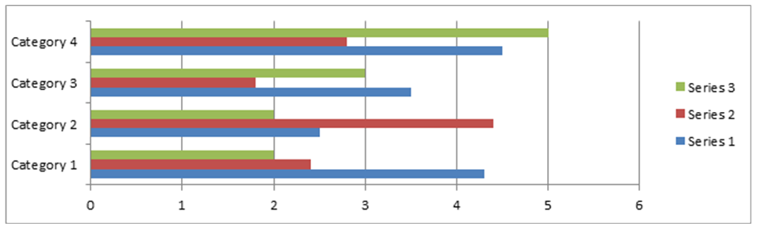
Fig. 1 Optimised electron gun geometry, electron trajectories and magnetic field.

References:
[1] G. Schmidt, “Nonadiabatic particle motion in axialsymmetric fields,” Phys. Fluids, 21, pp. 2354-2364, 1978.

