Instrumental Variables Regression
(SW Ch. 10)

Three important threats to internal validity are:

- omitted variable bias from a variable that is correlated with X but is unobserved, so cannot be included in the regression;
- simultaneous causality bias (X causes Y, Y causes X);
- errors-in-variables bias (X is measured with error)

Instrumental variables regression can eliminate bias from these three sources.

The IV Estimator with a Single Regressor and a Single Instrument (SW Section 10.1)

Y_{i} = β₀ + β₁X_{i} + u_{i}

- Loosely, IV regression breaks X into two parts: a part that might be correlated with u, and a part that is not. By isolating the part that is not correlated with u, it is possible to estimate β₁.
- This is done using an instrumental variable, Z_{i}, which is uncorrelated with u_{i}.
- The instrumental variable detects movements in X_{i} that are uncorrelated with u_{i}, and use these to estimate β₁.

Terminology: endogeneity and exogeneity

An endogenous variable is one that is correlated with u
An exogenous variable is one that is uncorrelated with u

Historical note: “Endogenous” literally means “determined within the system,” that is, a variable that is jointly determined with Y, that is, a variable subject to simultaneous causality. However, this definition is narrow and IV regression can be used to address omitted variable bias and errors-in-variable bias, not just simultaneous causality bias.

Two conditions for a valid instrument

Y_{i} = β₀ + β₁X_{i} + u_{i}

For an instrumental variable (an “instrument”) Z to be valid, it must satisfy two conditions:
- Instrument relevance: corr(Z_{i}, X_{i}) ≠ 0
- Instrument exogeneity: corr(Z_{i}, u_{i}) = 0

Suppose for now that you have such a Z_{i} (we’ll discuss how to find instrumental variables later). How can you use Z_{i} to estimate β₁?

The IV Estimator, one X and one Z
Explanation #1: Two Stage Least Squares (TSLS)
As it sounds, TSLS has two stages – two regressions:
(1) First isolates the part of X that is uncorrelated with u:
regress X_{i} on Z_{i ,} i = 1, …,N, using OLS

X_{i} = π₀ + π₁Z_{i} + v_{i} (1)

- Because Z_{i} is uncorrelated with u_{i}, π₀ + π₁Z_{i} is uncorrelated with u_{i}. We don’t know π₀ or π₁ but we have estimated them, so…
- Compute the predicted values of X_{i}, 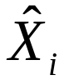, where = 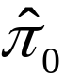 + 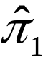Z_{i}, i = 1,…,n.
(2) Replace X_{i} by in the regression of interest:
regress Y_{i} on using OLS:

Y_{i} = β₀ + β₁ + u_{i} (2)

- Because is uncorrelated with u_{i} in large samples, so the first least squares assumption holds
- Thus β₁ can be estimated by OLS using regression (2)
- This argument relies on large samples (so π₀ and π₁ are well estimated using regression (1))
- The resulting estimator is called the “Two Stage Least Squares” (TSLS) estimator, 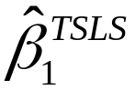.

is a consistent estimator of β₁.

The IV Estimator, one X and one Z, continued.
Explanation #2: (only) a little algebra
Y_{i} = β₀ + β₁X_{i} + u_{i}
Thus,
cov(Y_{i},Z_{i}) = cov(β₀ + β₁X_{i} + u_{i}, Z_{i})
= cov(β₀, Z_{i}) + cov(β₁X_{i}, Z_{i}) + cov(u_{i}, Z_{i})
= 0 + cov(β₁X_{i}, Z_{i}) + 0
= β₁cov(X_{i}, Z_{i})

where cov(u_{i}, Z_{i}) = 0 (instrument exogeneity); thus

β₁ = 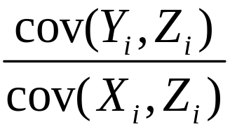

The IV estimator replaces these population covariances with sample covariances:

= 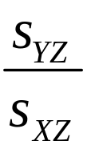,

S_{YZ} and S_{XZ} are the sample covariances.
This is the TSLS estimator – just a different derivation.

Consistency of the TSLS estimator

=

The sample covariances are consistent: S_{YZ} 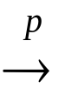 cov(Y,Z) and S_{XZ} cov(X,Z). Thus,
= 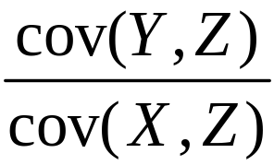 = β₁

- The instrument relevance condition, cov(X,Z) ≠ 0, ensures that you don’t divide by zero.

Example #1: Supply and demand for butter
IV regression was originally developed to estimate demand elasticities for agricultural goods, for example butter:
ln(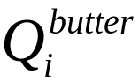) = β₀ + β₁ln(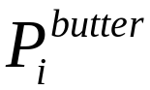) + u_{i}

- β₁ = price elasticity of butter = percent change in quantity for a 1% change in price (recall log-log specification discussion)
- Data: observations on price and quantity of butter for different years
- The OLS regression of ln() on ln() suffers from simultaneous causality bias (why?)
Simultaneous causality bias in the OLS regression of ln() on ln() arises because price and quantity are determined by the interaction of demand and supply
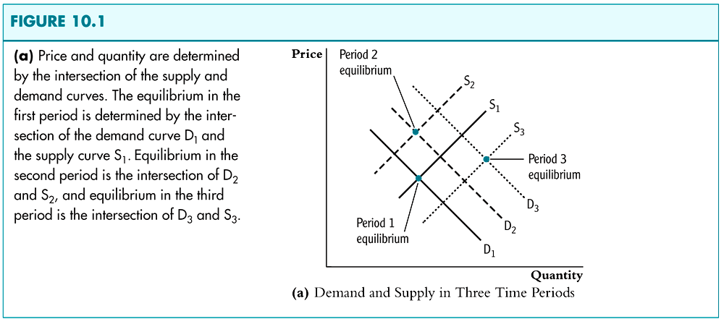

This interaction of demand and supply produces…
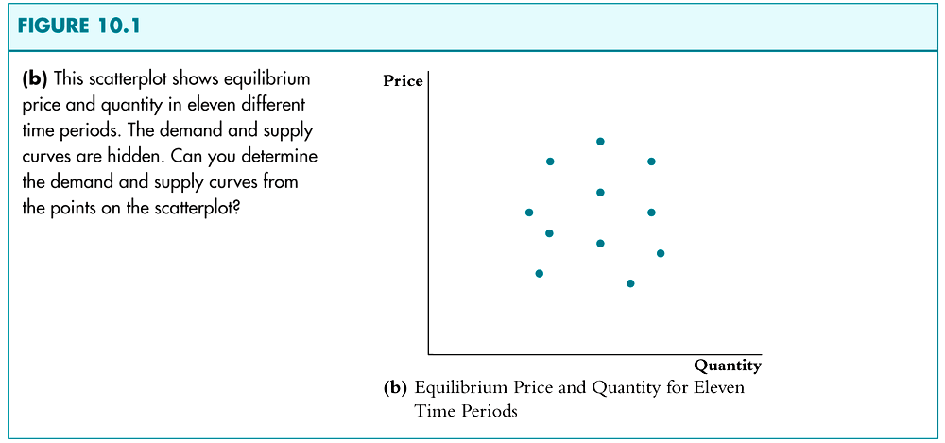
Would a regression using these data produce the demand curve?
What would you get if only supply shifted?
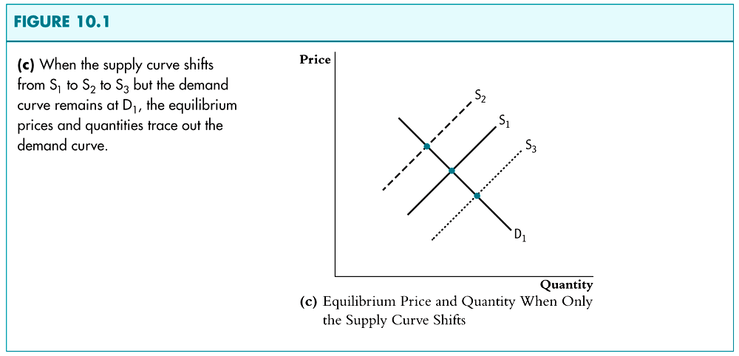

- TSLS estimates the demand curve by isolating shifts in price and quantity that arise from shifts in supply.
- Z is a variable that shifts supply but not demand.
TSLS in the supply-demand example:

ln() = β₀ + β₁ln() + u_{i}

Let Z = rainfall in dairy-producing regions.
Is Z a valid instrument?
(1) Exogenous? corr(rain_{i}, u_{i}) = 0?
Plausibly: whether it rains in dairy-producing regions shouldn’t affect demand
(2) Relevant? corr(rain_{i}, ln()) ≠ 0?
Plausibly: insufficient rainfall means less grazing means less butter

Stage 1: regress ln() on rain, get 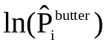
isolates changes in log price that arise from supply (part of supply, at least)

Stage 2: regress ln() on
The regression counterpart of using shifts in the supply curve to trace out the demand curve.
Inference using TSLS
- In large samples, the sampling distribution of the TSLS estimator is normal
- Inference (hypothesis tests, confidence intervals) proceeds in the usual way, e.g. ± 1.96SE
- The idea behind the large-sample normal distribution of the TSLS estimator is that – like all the other estimators we have considered – it involves an average of mean zero i.i.d. random variables, to which we can apply the Central Limit Theorem.

A lot of complicated math shows (see SW Chap 10 appendix):
is approx. distributed N(β₁,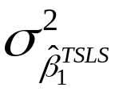),
where = 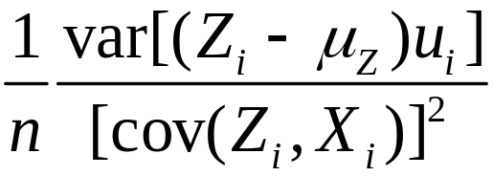.
Inference using TSLS, continued.
- Statistical inference proceeds in the usual way.
- The justification is (as usual) based on large samples
- This all assumes that the instruments are valid – we’ll discuss what happens if they aren’t valid shortly.

- Important note on standard errors:
  - The OLS standard errors from the second stage regression aren’t right – they don’t take into account the estimation in the first stage ( is estimated).
  - Instead, use a single specialized command that computes the TSLS estimator and the correct SEs.
  - as usual, use heteroskedasticity-robust SEs
Example: Demand for Cigarettes

- How much will a hypothetical cigarette tax reduce cigarette consumption?
- To answer this, we need the elasticity of demand for cigarettes, that is, β₁, in the regression,

ln(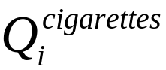) = β₀ + β₁ln(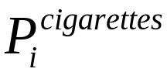) + u_{i}

- Will the OLS estimator plausibly be unbiased?
Why or why not?

Panel data:
- Annual cigarette consumption and average prices paid (including tax)
- 48 continental US states, 1985-1995
Proposed instrumental variable:
- Z_{i} = general sales tax per pack in the state = SalesTax_{i}
- Is this a valid instrument?
(1) Relevant? corr(SalesTax_{i}, ln()) ≠ 0?
(2) Exogenous? corr(SalesTax_{i}, u_{i}) = 0?
For now, use data for 1995 only.

PcGive Example: Cigarette demand, First stage OLS

EQ( 1) Modelling LogP by OLS-CS (using cig_ch1095)
The estimation sample is: 1 to 48

Coefficient Std.Error t-value t-prob Part.R^2
Constant 4.78891 0.02177 220. 0.000 0.9991
tax 0.00770695 0.0003896 19.8 0.000 0.8948

sigma 0.0418887 RSS 0.0807144209
R^2 0.894826 F(1,46) = 391.4 [0.000]**
log-likelihood 85.2039 DW 1.77
no. of observations 48 no. of parameters 2
lpfit [1 to 48] saved to cig_ch1095

Now we have the predicted values from the 1st stage, called lpfit
Second stage
EQ( 2) Modelling LogQ by OLS-CS (using cig_ch1095)
The estimation sample is: 1 to 48

Coefficient Std.Error t-value t-prob Part.R^2
Constant 10.5231 1.268 8.30 0.000 0.5997
lpfit -1.15023 0.2436 -4.72 0.000 0.3264

sigma 0.201876 RSS 1.87467169
R^2 0.326438 F(1,46) = 22.29 [0.000]**
log-likelihood 9.71737 DW 1.81
no. of observations 48 no. of parameters 2

- These coefficients are the TSLS estimates
- The standard errors are wrong because they ignore the fact that the first stage was estimated

Combined into a single command, using the IV option in PcGive:
EQ( 3) Modelling LogQ by IVE-CS (using cig_ch1095)
The estimation sample is: 1 to 48

Coefficient Std.Error t-value t-prob
LogP Y -1.15023 0.2290 -5.02 0.000
Constant 10.5231 1.192 8.83 0.000

sigma 0.189792 RSS 1.65695792
Reduced form sigma 0.20188
no. of observations 48 no. of parameters 2
no. endogenous variables 2 no. of instruments 2
mean(LogQ) 4.53884 var(LogQ) 0.0579838
Additional instruments:
[0] = tax
Testing beta = 0: Chi^2(1) = 25.223 [0.0000]**
------------------------------------------------------------------------------
Instrumented: LogP This is the endogenous regressor
Instruments: tax This is the instrumental variable
------------------------------------------------------------------------------

OK, the change in the SEs was small this time...but not always!
2SLS Results:
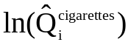= 10.52 – 1.15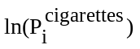, n = 48
(1.19) (0.23)

The General IV Regression Model
(SW Section 10.2)

- So far we have considered IV regression with a single endogenous regressor (X) and a single instrument (Z).
- We need to extend this to:
  - multiple endogenous regressors (X₁,…, X_{k})
  - multiple included exogenous variables (W₁,…, W_{r})
These need to be included for the usual OV reason
  - multiple instrumental variables (Z₁,…, Z_{m})
More (relevant) instruments can produce a smaller variance of TSLS: the R² of the first stage increases, so you have more variation in 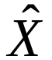.

Example: cigarette demand

- Another determinant of cigarette demand is income; omitting income could result in omitted variable bias
- Cigarette demand with one X, one W, and 2 instruments (2 Z’s):
ln() = β₀ + β₁ln() + β₂ln(Income_{i}) + u_{i}

Z_{1i} = general sales tax component only_{i}
Z_{2i} = cigarette-specific tax component only_{i}

- Other W’s might be state effects and/or year effects (in panel data, later…)

The general IV regression model: notation and jargon

Y_{i} = β₀ + β₁X_{1i} + … + β_{k}X_{ki} + β_{k+1}W_{1i} + … + β_{k+r}W_{ri} + u_{i}

- Y_{i} is the dependent variable
- X_{1i},…, X_{ki} are the endogenous regressors (potentially correlated with u_{i})
- W_{1i},…,W_{ri} are the included exogenous variables or included exogenous regressors (uncorrelated with u_{i})
- β₀, β₁,…, β_{k+r} are the unknown regression coefficients
- Z_{1i},…,Z_{mi} are the m instrumental variables (the excluded exogenous variables)

We need to introduce some new concepts and to extend some old concepts to the general IV regression model:
- Terminology: identification and overidentification
- TSLS with included exogenous variables
  - one endogenous regressor
  - multiple endogenous regressors
- Assumptions that underlie the normal sampling distribution of TSLS
  - Instrument validity (relevance and exogeneity)
  - General IV regression assumptions
Identification

- In general, a parameter is said to be identified if different values of the parameter would produce different distributions of the data.
- In IV regression, whether the coefficients are identified depends on the relation between the number of instruments (m) and the number of endogenous regressors (k)
- Intuitively, if there are fewer instruments than endogenous regressors, we can’t estimate β₁,…,β_{k}
- For example, suppose k = 1 but m = 0 (no instruments)!

The coefficients β₁,…,β_{k} are said to be:
- exactly identified if m = k.
There are just enough instruments to estimate β₁,…,β_{k}.
- overidentified if m > k.
There are more than enough instruments to estimate β₁,…,β_{k}. If so, you can test whether the instruments are valid (a test of the “overidentifying restrictions”) – we’ll return to this later
- underidentified if m < k.
There are too few enough instruments to estimate β₁,…,β_{k}. If so, you need to get more instruments!

General IV regression: TSLS, 1 endogenous regressor
Y_{i} = β₀ + β₁X_{1i} + β₂W_{1i} + … + β_{1+r}W_{ri} + u_{i}

- Instruments: Z_{1i},…,Z_{m}
- First stage
  - Regress X₁ on all the exogenous regressors: regress X₁ on W₁,…,W_{r},Z₁,…,Z_{m} by OLS
  - Compute predicted values 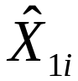, i = 1,…,n
- Second stage
  - Regress Y on 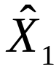,W₁,…,W_{r} by OLS
  - The coefficients from this second stage regression are the TSLS estimators, but SEs are wrong
- To get correct SEs, do this in a single step

Example: Demand for cigarettes

ln() = β₀ + β₁ln() + β₂ln(Income_{i}) + u_{i}

Z_{1i} = general sales tax_{i}
Z_{2i} = cigarette-specific tax_{i}

- Endogenous variable: ln() (“one X”)
- Included exogenous variable: ln(Income_{i}) (“one W”)
- Instruments (excluded endogenous variables): general sales tax, cigarette-specific tax (“two Zs”)
- Is the demand elasticity β₁ overidentified, exactly identified, or underidentified?
Example: Cigarette demand, one instrument

Algebra code for cig_ch1095:
pcinc = income/pop;
Lpcinc = log(pcinc);

EQ( 6) Modelling LogQ by IVE-CS (using cig_ch1095)
The estimation sample is: 1 to 48

Coefficient Std.Error t-value t-prob
LogP Y -1.31458 0.2711 -4.85 0.000
Constant 10.4517 1.175 8.90 0.000
Lpcinc 0.298666 0.2405 1.24 0.221

sigma 0.187586 RSS 1.58348587
Reduced form sigma 0.20274
no. of observations 48 no. of parameters 3
no. endogenous variables 2 no. of instruments 3
mean(LogQ) 4.53884 var(LogQ) 0.0579838
Additional instruments:
[0] = tax
Testing beta = 0: Chi^2(2) = 26.530 [0.0000]**

Instrumented: Log(P)
Instruments:

- Running IV as a single command yields correct SEs

Example: Cigarette demand, two instruments
EQ( 7) Modelling LogQ by IVE-CS (using cig_ch1095)
The estimation sample is: 1 to 48

Coefficient Std.Error t-value t-prob
LogP Y -1.27742 0.2632 -4.85 0.000
Constant 10.3150 1.151 8.96 0.000
Lpcinc 0.280405 0.2386 1.18 0.246

sigma 0.187856 RSS 1.58804447
Reduced form sigma 0.20421
no. of observations 48 no. of parameters 3
no. endogenous variables 2 no. of instruments 4
mean(LogQ) 4.53884 var(LogQ) 0.0579838
Additional instruments:
[0] = tax
[1] = taxs

Specification test: Chi^2(1) = 0.33262 [0.5641]
Testing beta = 0: Chi^2(2) = 26.562 [0.0000]**

Y W X Z₁ Z₂
Log(Q) Log(P) Lpcinc tax taxs

Instrumented: Log(P)
Instruments: tax taxs
S
- Smaller SEs for m = 2. Using 2 instruments gives more information – more “as-if random variation”.
- Low income elasticity (not a luxury good); income elasticity not statistically significantly different from 0
- Surprisingly high price elasticity

General IV regression: TSLS with multiple endogenous regressors

Y_{i} = β₀ + β₁X_{1i} + … + β_{k}X_{ki} + β_{k+1}W_{1i} + … + β_{k+r}W_{ri} + u_{i}

- Instruments: Z_{1i},…,Z_{m}
- Now there are k first stage regressions:
  - Regress X₁ on W₁,…, W_{r}, Z₁,…, Z_{m} by OLS
  - Compute predicted values , i = 1,…,n
  - Regress X₂ on W₁,…, W_{r}, Z₁,…, Z_{m} by OLS
  - Compute predicted values 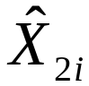, i = 1,…,n
  - Repeat for all X’s, obtaining , ,…, 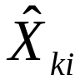

- Second stage
  - Regress Y on , ,…, , W₁,…, W_{r} by OLS
  - The coefficients from this second stage regression are the TSLS estimators, but SEs are wrong
- To get correct SEs, do this in a single step
- What would happen in the second stage regression if the coefficients were underidentified (that is, if #instruments < #endogenous variables); for example, if k = 2, m = 1?

Sampling distribution of the TSLS estimator in the general IV regression model

- Meaning of “valid” instruments in the general case
- The IV regression assumptions
- Implications: if the IV regression assumptions hold, then the TSLS estimator is normally distributed, and inference (testing, confidence intervals) proceeds as usual

A “valid” set of instruments in the general case

The set of instruments must be relevant and exogenous:

1. Instrument relevance: Special case of one X
At least one instrument must enter the population counterpart of the first stage regression.

2. Instrument exogeneity
All the instruments are uncorrelated with the error term: corr(Z_{1i},u_{i}) = 0,…, corr(Z_{m}, u_{i}) = 0

“Valid” instruments in the general case.

(1) General instrument relevance condition:
- General case, multiple X’s
Suppose the second stage regression could be run using the predicted values from the population first stage regression. Then: there is no perfect multicollinearity in this (infeasible) second stage regression
- Special case of one X
At least one instrument must enter the population counterpart of the first stage regression.

The IV Regression Assumptions
Y_{i} = β₀ + β₁X_{1i} + … + β_{k}X_{ki} + β_{k+1}W_{1i} + … + β_{k+r}W_{ri} + u_{i}

- E(u_{i}|W_{1i},…,W_{ri}) = 0
- (Y_{i},X_{1i},…,X_{ki},W_{1i},…,W_{ri},Z_{1i},…,Z_{mi}) are i.i.d.
- The X’s, W’s, Z’s, and Y have nonzero, finite 4th moments
- The W’s are not perfectly multicollinear
- The instruments (Z_{1i},…,Z_{mi}) satisfy the conditions for a valid set of instruments.
- #1 says “the exogenous regressors are exogenous.”
- #2 – #4 are not new; we have discussed #5.
Implications: Sampling distribution of TSLS

- If the IV regression assumptions hold, then the TSLS estimator is normally distributed in large samples.
- Inference (hypothesis testing, confidence intervals) proceeds as usual.
- Two notes about standard errors:
  - The second stage SEs are incorrect because they don’t take into account estimation in the first stage; to get correct SEs, run TSLS in a single command
  - Use heteroskedasticity-robust SEs, for the usual reason.
- All this hinges on having valid instruments…

Checking Instrument Validity
(SW Section 10.3)

Recall the two requirements for valid instruments:
1. Relevance (special case of one X)
At least one instrument must enter the population counterpart of the first stage regression.
2. Exogeneity
All the instruments must be uncorrelated with the error term: corr(Z_{1i},u_{i}) = 0,…, corr(Z_{mi}, u_{i}) = 0

What happens if one of these requirements isn’t satisfied? How can you check? And what do you do? Checking Assumption #1: Instrument Relevance
We will focus on a single included endogenous regressor:
Y_{i} = β₀ + β₁X_{i} + β₂W_{1i} + … + β_{1+r}W_{ri} + u_{i}

First stage regression:
X_{i} = π₀ + π₁Z_{1i} +…+ π_{mi}Z_{mi} + π_{m+1i}W_{1i} +…+ π_{m+ki}W_{ki} + u_{i}

- The instruments are relevant if at least one of π₁,…,π_{m} are nonzero.
- The instruments are said to be weak if all the π₁,…,π_{m} are either zero or nearly zero.
- Weak instruments explain very little of the variation in X, beyond that explained by the W’s
What are the consequences of weak instruments?

Consider the simplest case:
Y_{i} = β₀ + β₁X_{i} + u_{i}
X_{i} = π₀ + π₁Z_{i} + u_{i}

- The IV estimator is =
- If cov(X,Z) is zero or small, then s_{XZ} will be small: With weak instruments, the denominator is nearly zero.
- If so, the sampling distribution of (and its t-statistic) is not well approximated by its large-n normal approximation…
An example: the distribution of the TSLS t-statistic with weak instruments
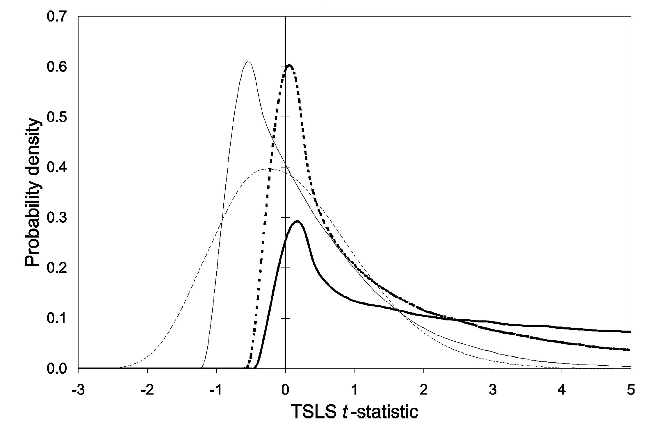
Dark line = irrelevant instruments
Dashed light line = strong instruments
Why does our trusty normal approximation fail us!?!
=
- If cov(X,Z) is small, small changes in S_{XZ} (from one sample to the next) can induce big changes in
- Suppose in one sample you calculate S_{XZ} = .00001!
- Thus the large-n normal approximation is a poor approximation to the sampling distribution of
- A better approximation is that is distributed as the ratio of two correlated normal random variables (see SW App. 10.4)
- If instruments are weak, the usual methods of inference are unreliable – potentially very unreliable.
Measuring the strength of instruments in practice:
The first-stage F-statistic

- The first stage regression (one X):
Regress X on Z₁,..,Z_{m},W₁,…,W_{k}.
- Totally irrelevant instruments  all the coefficients on Z₁,…,Z_{m} are zero.
- The first-stage F-statistic tests the hypothesis that Z₁,…,Z_{m} do not enter the first stage regression.
- Weak instruments imply a small first stage F-statistic.
Checking for weak instruments with a single X
- Compute the first-stage F-statistic.
Rule-of-thumb: If the first stage F-statistic is less than 10, then the set of instruments is weak.
- If so, the TSLS estimator will be biased, and statistical inferences (standard errors, hypothesis tests, confidence intervals) can be misleading.
- Note that simply rejecting the null hypothesis of that the coefficients on the Z’s are zero isn’t enough – you actually need substantial predictive content for the normal approximation to be a good one.
- There are more sophisticated things to do than just compare F to 10 but they are beyond this course.
What to do if you have weak instruments?

- Get better instruments (!)
- If you have many instruments, some are probably weaker than others and it’s a good idea to drop the weaker ones (dropping an irrelevant instrument will increase the first-stage F)
- Use a different IV estimator instead of TSLS
  - There are many IV estimators available when the coefficients are overidentified.
  - Limited information maximum likelihood has been found to be less affected to weak instruments.
  - all this is beyond the scope of this course…

Checking Assumption #2: Instrument Exogeneity

- Instrument exogeneity: All the instruments are uncorrelated with the error term: corr(Z_{1i},u_{i}) = 0,…, corr(Z_{mi}, u_{i}) = 0
- If the instruments aren’t correlated with the error term, the first stage of TSLS doesn’t successfully isolate a component of X that is uncorrelated with the error term, so is correlated with u and TSLS is inconsistent.
- If there are more instruments than endogenous regressors, it is possible to test – partially – for instrument exogeneity.

Testing overidentifying restrictions

Consider the simplest case:
Y_{i} = β₀ + β₁X_{i} + u_{i},

- Suppose there are two valid instruments: Z_{1i}, Z_{2i}
- Then you could compute two separate TSLS estimates.
- Intuitively, if these 2 TSLS estimates are very different from each other, then something must be wrong: one or the other (or both) of the instruments must be invalid.
- The J-test of overidentifying restrictions makes this comparison in a statistically precise way.
- This can only be done if #Z’s > #X’s (overidentified).
Suppose #instruments = m > # X’s = k (overidentified)
Y_{i} = β₀ + β₁X_{1i} + … + β_{k}X_{ki} + β_{k+1}W_{1i} + … + β_{k+r}W_{ri} + u_{i}

The J-test of overidentifying restrictions
- First estimate the equation of interest using TSLS and all m instruments; compute the predicted values 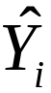, using the actual X’s (not the ’s used to estimate the second stage)
- Compute the residuals 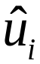 = Y_{i} –
- Regress against Z_{1i},…,Z_{mi}, W_{1i},…,W_{ri}
- Compute the F-statistic testing the hypothesis that the coefficients on Z_{1i},…,Z_{mi} are all zero;
- The J-statistic is J = mFJ = mF, where F = the F-statistic testing the coefficients on Z_{1i},…,Z_{mi} in a regression of the TSLS residuals against Z_{1i},…,Z_{mi}, W_{1i},…,W_{ri}.

Distribution of the J-statistic
- Under the null hypothesis that all the instruments are exogeneous, J has a chi-squared distribution with m–k degrees of freedom
- If m = k, J = 0 (does this make sense?)
- If some instruments are exogenous and others are endogenous, the J statistic will be large, and the null hypothesis that all instruments are exogenous will be rejected.

Application to the Demand for Cigarettes
(SW Section 10.4)

Why are we interested in knowing the elasticity of demand for cigarettes?
- Theory of optimal taxation: optimal tax is inverse to elasticity: smaller deadweight loss if quantity is affected less.
- Externalities of smoking – role for government intervention to discourage smoking
  - second-hand smoke (non-monetary)
  - monetary externalities
Panel data set
- Annual cigarette consumption, average prices paid by end consumer (including tax), personal income
- 48 continental US states, 1985-1995

Estimation strategy
- Having panel data allows us to control for unobserved state-level characteristics that enter the demand for cigarettes, as long as they don’t vary over time
- But we still need to use IV estimation methods to handle the simultaneous causality bias that arises from the interaction of supply and demand.
Fixed-effects model of cigarette demand

ln(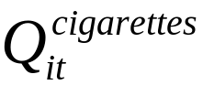) = α_{i} + β₁ln(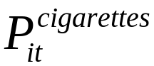) + β₂ln(Income_{it}) + u_{it}

- i = 1,…,48, t = 1985, 1986,…,1995
- α_{i} reflects unobserved omitted factors that vary across states but not over time, e.g. attitude towards smoking
- Still, corr(ln(),u_{it}) is plausibly nonzero because of supply/demand interactions
- Estimation strategy:
  - Use panel data regression methods to eliminate α_{i}
  - Use TSLS to handle simultaneous causality bias

Panel data IV regression: two approaches
(a) The “n-1 binary indicators” method
(b) The “changes” method (when T=2)

(a) The “n-1 binary indicators” method
Rewrite
ln() = α_{i} + β₁ln() + β₂ln(Income_{it}) + u_{it}
as
ln() = β₀ + β₁ln() + β₂ln(Income_{it})
+ γ₂D2_{it} + … + γ₄₈D48_{it} + u_{it}
Instruments:
Z_{1it} = general sales tax_{it}
Z_{2it} = cigarette-specific tax_{it}
This now fits in the general IV regression model:

ln() = β₀ + β₁ln() + β₂ln(Income_{it})
+ γ₂D2_{it} + … + γ₄₈D48_{it} + u_{it}

- X (endogenous regressor) = ln()
- 48 W’s (included exogenous regressors) = ln(Income_{it}), D2_{it},…, D48_{it}
- Two instruments = Z_{1it}, Z_{2it}
- Now estimate this full model using TSLS!
- An issue arises when dynamic response (lagged adjustment) is important, as it is here – it takes time to kick smoking – how to model lagged effects?
(b) The “changes” method (when T=2)
- One way to model long-term effects is to consider 10-year changes, between 1985 and 1995
- Rewrite the regression in “changes” form:
ln(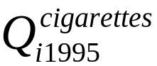) – ln(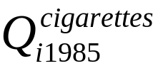)
= β₁[ln(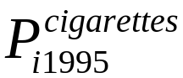) – ln(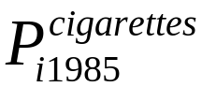)]
+β₂[ln(Income_{i1995}) – ln(Income_{i1985})]
+ (u_{i1995} – u_{i1985})
- Must create “10-year change” variables, for example:
10-year change in log price = ln(P_{i1995}) – ln(P_{i1985})
- Then estimate the demand elasticity by TSLS using 10-year changes in the instrumental variables
- We’ll take this approach

STATA: Cigarette demand

First create “10-year change” variables
10-year change in log price
= ln(P_{it}) – ln(P_{it–10}) = ln(P_{it}/P_{it–10})

. gen dlpackpc = log(packpc/packpc[_n-10]); _n-10 is the 10-yr lagged value
. gen dlavgprs = log(avgprs/avgprs[_n-10]);
. gen dlperinc = log(perinc/perinc[_n-10]);
. gen drtaxs = rtaxs-rtaxs[_n-10];
. gen drtax = rtax-rtax[_n-10];
. gen drtaxso = rtaxso-rtaxso[_n-10];

Use TSLS to estimate the demand elasticity by using the “10-year changes” specification
Y W X Z
. ivreg dlpackpc dlperinc (dlavgprs = drtaxso) , r;

IV (2SLS) regression with robust standard errors Number of obs = 48
F( 2, 45) = 12.31
Prob > F = 0.0001
R-squared = 0.5499
Root MSE = .09092

------------------------------------------------------------------------------
| Robust
dlpackpc | Coef. Std. Err. t P>|t| [95% Conf. Interval]
-------------+----------------------------------------------------------------
dlavgprs | -.9380143 .2075022 -4.52 0.000 -1.355945 -.5200834
dlperinc | .5259693 .3394942 1.55 0.128 -.1578071 1.209746
_cons | .2085492 .1302294 1.60 0.116 -.0537463 .4708446
------------------------------------------------------------------------------
Instrumented: dlavgprs
Instruments: dlperinc drtaxso
------------------------------------------------------------------------------
NOTE:
- All the variables – Y, X, W, and Z’s – are in 10-year changes
- Estimated elasticity = –.94 (SE = .21) – surprisingly elastic!
- Income elasticity small, not statistically different from zero
- Must check whether the instrument is relevant…
Check instrument relevance: compute first-stage F

. reg dlavgprs drtaxso dlperinc , r;

Regression with robust standard errors Number of obs = 48
F( 2, 45) = 16.84
Prob > F = 0.0000
R-squared = 0.5146
Root MSE = .06334

------------------------------------------------------------------------------
| Robust
dlavgprs | Coef. Std. Err. t P>|t| [95% Conf. Interval]
-------------+----------------------------------------------------------------
drtaxso | .0254611 .0043876 5.80 0.000 .016624 .0342982
dlperinc | -.2241037 .2188815 -1.02 0.311 -.6649536 .2167463
_cons | .5321948 .0295315 18.02 0.000 .4727153 .5916742
------------------------------------------------------------------------------

. test drtaxso; We didn’t need to run “test” here
because with m=1 instrument, the
( 1) drtaxso = 0 F-statistic is the square of the
t-statistic, that is,
F( 1, 45) = 33.67 5.80*5.80 = 33.67
Prob > F = 0.0000
First stage F = 33.7 > 10 so instrument is not weak

Can we check instrument exogeneity? No…m = k
What about two instruments (cig-only tax, sales tax)?

. ivreg dlpackpc dlperinc (dlavgprs = drtaxso drtax) , r;

IV (2SLS) regression with robust standard errors Number of obs = 48
F( 2, 45) = 21.30
Prob > F = 0.0000
R-squared = 0.5466
Root MSE = .09125

------------------------------------------------------------------------------
| Robust
dlpackpc | Coef. Std. Err. t P>|t| [95% Conf. Interval]
-------------+----------------------------------------------------------------
dlavgprs | -1.202403 .1969433 -6.11 0.000 -1.599068 -.8057392
dlperinc | .4620299 .3093405 1.49 0.142 -.1610138 1.085074
_cons | .3665388 .1219126 3.01 0.004 .1209942 .6120834
------------------------------------------------------------------------------
Instrumented: dlavgprs
Instruments: dlperinc drtaxso drtax
------------------------------------------------------------------------------

drtaxso = general sales tax only
drtax = cigarette-specific tax only
Estimated elasticity is -1.2, even more elastic than using general
sales tax only

With m>k, we can test the overidentifying restrictions
Test the overidentifying restrictions

. predict e, resid; Computes predicted values for most recently
estimated regression (the previous TSLS regression)
. reg e drtaxso drtax dlperinc; Regress e on Z’s and W’s

Source | SS df MS Number of obs = 48
-------------+------------------------------ F( 3, 44) = 1.64
Model | .037769176 3 .012589725 Prob > F = 0.1929
Residual | .336952289 44 .007658007 R-squared = 0.1008
-------------+------------------------------ Adj R-squared = 0.0395
Total | .374721465 47 .007972797 Root MSE = .08751

------------------------------------------------------------------------------
e | Coef. Std. Err. t P>|t| [95% Conf. Interval]
-------------+----------------------------------------------------------------
drtaxso | .0127669 .0061587 2.07 0.044 .000355 .0251789
drtax | -.0038077 .0021179 -1.80 0.079 -.008076 .0004607
dlperinc | -.0934062 .2978459 -0.31 0.755 -.6936752 .5068627
_cons | .002939 .0446131 0.07 0.948 -.0869728 .0928509
------------------------------------------------------------------------------
. test drtaxso drtax;

( 1) drtaxso = 0 Compute J-statistic, which is m*F,
( 2) drtax = 0 where F tests whether coefficients on
the instruments are zero
F( 2, 44) = 2.47 so J = 2  2.47 = 4.93
Prob > F = 0.0966 ** WARNING – this uses the wrong d.f. **

The correct degrees of freedom for the J-statistic is m–k:
- J = mF, where F = the F-statistic testing the coefficients on Z_{1i},…,Z_{mi} in a regression of the TSLS residuals against Z_{1i},…,Z_{mi}, W_{1i},…,W_{mi}.
- Under the null hypothesis that all the instruments are exogeneous, J has a chi-squared distribution with m–k degrees of freedom
- Here, J = 4.93, distributed chi-squared with d.f. = 1; the 5% critical value is 3.84, so reject at 5% sig. level.
- In STATA:

. dis "J-stat = " r(df)*r(F) " p-value = " chiprob(r(df)-1,r(df)*r(F));
J-stat = 4.9319853 p-value = .02636401

J = 2  2.47 = 4.93 p-value from chi-squared(1) distribution
Check instrument relevance: compute first-stage F
X Z1 Z2 W
. reg dlavgprs drtaxso drtax dlperinc , r;

Regression with robust standard errors Number of obs = 48
F( 3, 44) = 66.68
Prob > F = 0.0000
R-squared = 0.7779
Root MSE = .04333

------------------------------------------------------------------------------
| Robust
dlavgprs | Coef. Std. Err. t P>|t| [95% Conf. Interval]
-------------+----------------------------------------------------------------
drtaxso | .013457 .0031405 4.28 0.000 .0071277 .0197863
drtax | .0075734 .0008859 8.55 0.000 .0057879 .0093588
dlperinc | -.0289943 .1242309 -0.23 0.817 -.2793654 .2213767
_cons | .4919733 .0183233 26.85 0.000 .4550451 .5289015
------------------------------------------------------------------------------

. test drtaxso drtax;

( 1) drtaxso = 0
( 2) drtax = 0

F( 2, 44) = 88.62 88.62 > 10 so instruments aren’t weak
Prob > F = 0.0000
Tabular summary of these results:
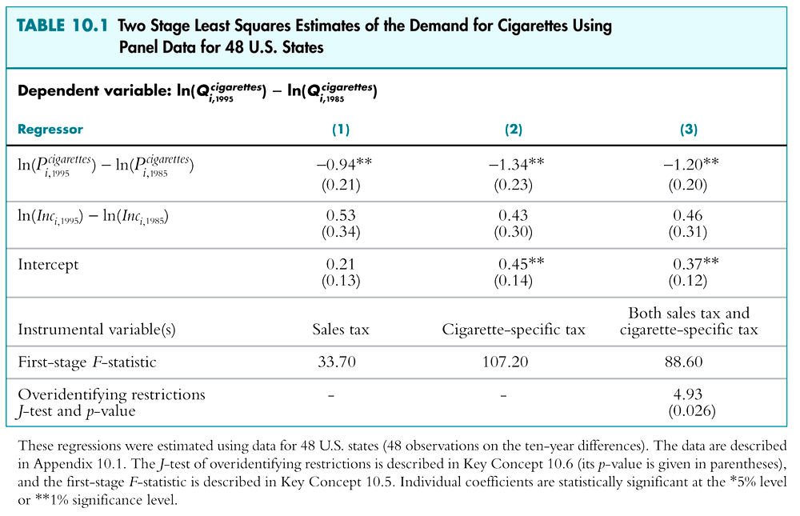
How should we interpret the J-test rejection?
- J-test rejects the null hypothesis that both the instruments are exogenous
- This means that either rtaxso is endogenous, or rtax is endogenous, or both
- The J-test doesn’t tell us which!! You must think!
- Why might rtax (cig-only tax) be endogenous?
  - Political forces: history of smoking or lots of smokers  political pressure for low cigarette taxes
  - If so, cig-only tax is endogenous
- This reasoning doesn’t apply to general sales tax
-  use just one instrument, the general sales tax
The Demand for Cigarettes:
Summary of Empirical Results

- Use the estimated elasticity based on TSLS with the general sales tax as the only instrument:
Elasticity = -.94, SE = .21
- This elasticity is surprisingly large (not inelastic) – a 1% increase in prices reduces cigarette sales by nearly 1%. This is much more elastic than conventional wisdom in the health economics literature.
- This is a long-run (ten-year change) elasticity. What would you expect a short-run (one-year change) elasticity to be – more or less elastic?
What are the remaining threats to internal validity?

- Omitted variable bias?
  - Panel data estimator; probably OK

- Functional form mis-specification
  - Hmmm…should check…
  - A related question is the interpretation of the elasticity: using 10-year differences, the elasticity interpretation is long-term. Different estimates would obtain using shorter differences.
Remaining threats to internal validity, ctd.
- Remaining simultaneous causality bias?
  - Not if the general sales tax a valid instrument:
    - relevance?
    - exogeneity?
- Errors-in-variables bias? Interesting question: are we accurately measuring the price actually paid? What about cross-border sales?
- Selection bias? (no, we have all the states)

Overall, this is a credible estimate of the long-term elasticity of demand although some problems might remain.

Where Do Valid Instruments Come From?
(SW Section 10.5)

- Valid instruments are (1) relevant and (2) exogenous
- One general way to find instruments is to look for exogenous variation – variation that is “as if” randomly assigned in a randomized experiment – that affects X.
  - Rainfall shifts the supply curve for butter but not the demand curve; rainfall is “as if” randomly assigned
  - Sales tax shifts the supply curve for cigarettes but not the demand curve; sales taxes are “as if” randomly assigned
- Here is a final example…
Example: Cardiac Catheterization

Does cardiac catheterization improve longevity of heart attack patients?

Y_{i} = survival time (in days) of heart attack patient
X_{i} = 1 if patient receives cardiac catheterization,
= 0 otherwise

- Clinical trials show that CardCath affects SurvivalDays.
- But is the treatment effective “in the field”?
SurvivalDays_{i} = β₀ + β₁CardCath_{i} + u_{i}

- Is OLS unbiased? The decision to treat a patient by cardiac catheterization is endogenous – it is (was) made in the field by EMT technician depends on u_{i} (unobserved patient health characteristics)
- If healthier patients are catheterized, then OLS has simultaneous causality bias and OLS overstates overestimates the CC effect
- Propose instrument: distance to the nearest CC hospital – distance to the nearest “regular” hospital
- Z = differential distance to CC hospital
  - Relevant? If a CC hospital is far away, patient won’t bet taken there and won’t get CC
  - Exogenous? If distance to CC hospital doesn’t affect survival, other than through effect on CardCath_{i}, then corr(distance,u_{i}) = 0 so exogenous
  - If patients location is random, then differential distance is “as if” randomly assigned.
  - The 1st stage is a linear probability model: distance affects the probability of receiving treatment
- Results (McClellan, McNeil, Newhous, JAMA, 1994):
  - OLS estimates significant and large effect of CC
  - TSLS estimates a small, often insignificant effect
Summary: IV Regression
(SW Section 10.6)
- A valid instrument lets us isolate a part of X that is uncorrelated with u, and that part can be used to estimate the effect of a change in X on Y
- IV regression hinges on having valid instruments:
- Relevance: check via first-stage F
- Exogeneity: Test overidentifying restrictions
- via the J-statistic
- A valid instrument isolates variation in X that is “as if” randomly assigned.
- The critical requirement of at least m valid instruments cannot be tested – you must use your head.

